<BDM Mid-Sem Submission>Analysis Of Stationery Sales

short line

Kanishk Bajpai   
(21f2000784)  
2nd March, 2023

Submitted To:  
IIT MADRAS, BDM TEAM

# Introduction

1. Executive Summary & Title
2. Proof of originality of the Data
3. Metadata and Descriptive Statistics
4. Detailed Explanation of Analysis Process/Method
5. Results and Findings

# Executive Summary & Title

This capstone project is intended to help a stationery shop owner to understand the strategies he has to implement after analyzing sales data of the 2 years, and to maximize and stabilize the profit in the principal revenue he produces from selling Stationery items, and help with his sales.  
The shop also deals with Telecom businesses & in the area of Photocopy as well.  
[Baba Vishwanath Photocopy And Recharge Centre](https://www.google.com/maps/place/Baba+Vishwanath+Photocopy+And+Recharge+Centre/@26.4157724,80.3860761,19.72z/data=!4m5!3m4!1s0x399c4122ef08779d:0x6f1b87534ddece20!8m2!3d26.4156245!4d80.3861731?shorturl=1)

I have got a **short cumulative Stationery data** to analyze…  
[Stationery Sales](https://docs.google.com/spreadsheets/d/1RTkyi8UMs-HI-HT_Q220cutizNWrR9ICXyFosw5dYVI/edit#gid=393801185)

With the Dataset that I have as part of the project, I will be able to help the stationery shop owner, that he should choose to sell, with the amount of supplies of these items that he should sell to make profit and also help him to manage stock outs and some other business related problems.

The primary goal of this project so far is to examine the sales trends in order to improve the store’s ability to generate revenue from this category. Because of the launch of new products into the businesses, sellers constantly face the prospect of not reflecting a stable relation with customers & timely customer reviews.

The most appropriate title for this project would be **"Analysis of Stationery Sales"** because it focuses on resolving challenges faced by a Stationery Shop using information from trend analysis.  
  
As I am currently in IIIT Dharwad, Karnataka, I faced difficulty in asking about this data from my relative residing in Kanpur, UP, about 2000 km away from me, because he doesn’t know how to use technical stuff, I faced difficulty in getting the data one by one, and uploading and organising it accordingly…till now it’s not completed yet…still going on..

# Additional Miscellaneous Problem faced:

1. Not Using UPI/ QR Code as a convenient and an additional mode of transaction.
2. Not having global online reach using website or any application
3. Not there in affiliate Marketing
4. No Marketing / Advertisements

# 

# Proof of Originality of the Data

The following are the images of the Shop:

Address:

183, Subhash Road, Ramgali, Harjinder Nagar, Ramadevi, Lal Bangla, Kanpur, Kanpur Nagar, Uttar Pradesh 208007  
[Baba Vishwanath Photocopy And Recharge Centre](https://www.google.com/maps/place/Baba+Vishwanath+Photocopy+And+Recharge+Centre/@26.4157724,80.3860761,19.72z/data=!4m5!3m4!1s0x399c4122ef08779d:0x6f1b87534ddece20!8m2!3d26.4156245!4d80.3861731?shorturl=1)

[Click Here to get its Google location](https://goo.gl/maps/1mv51gmmFxKToyoPA)

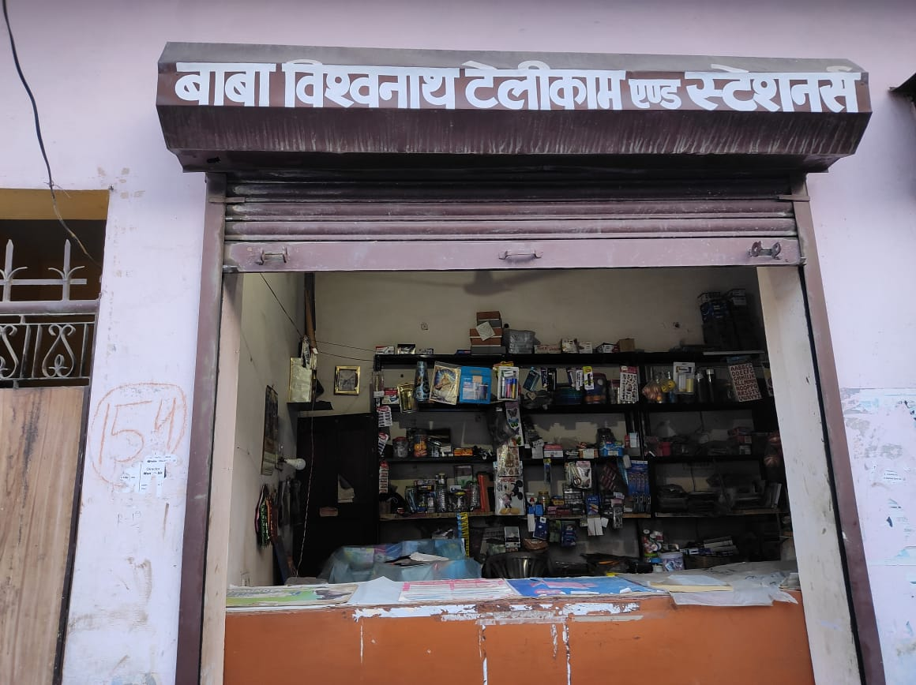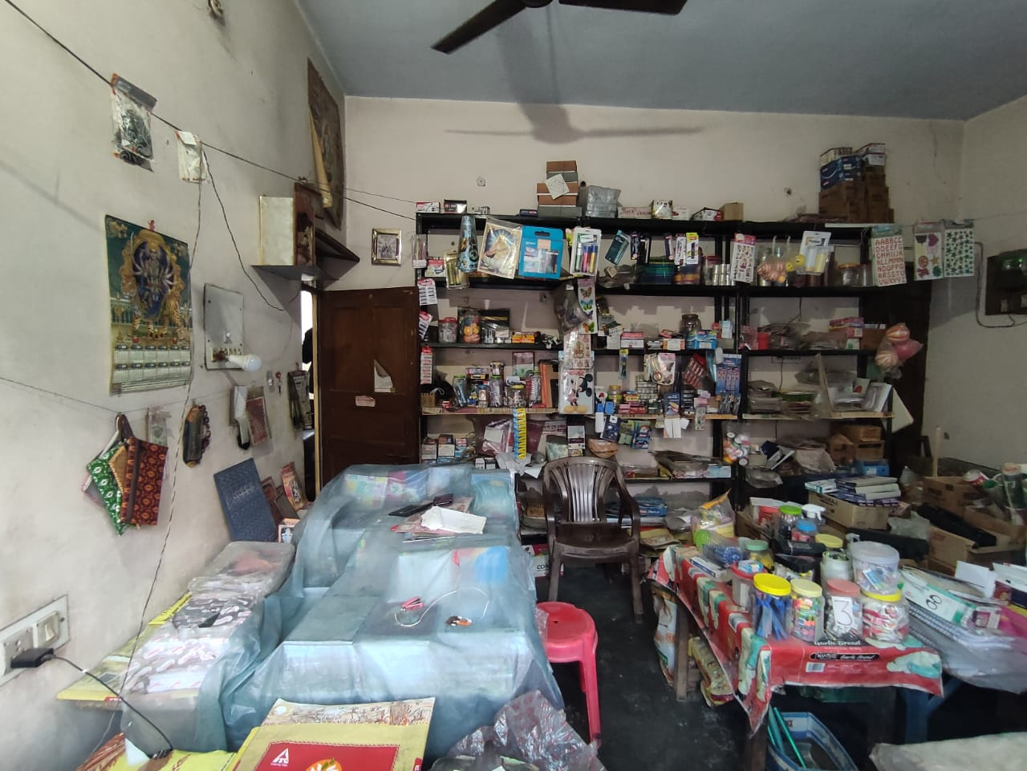

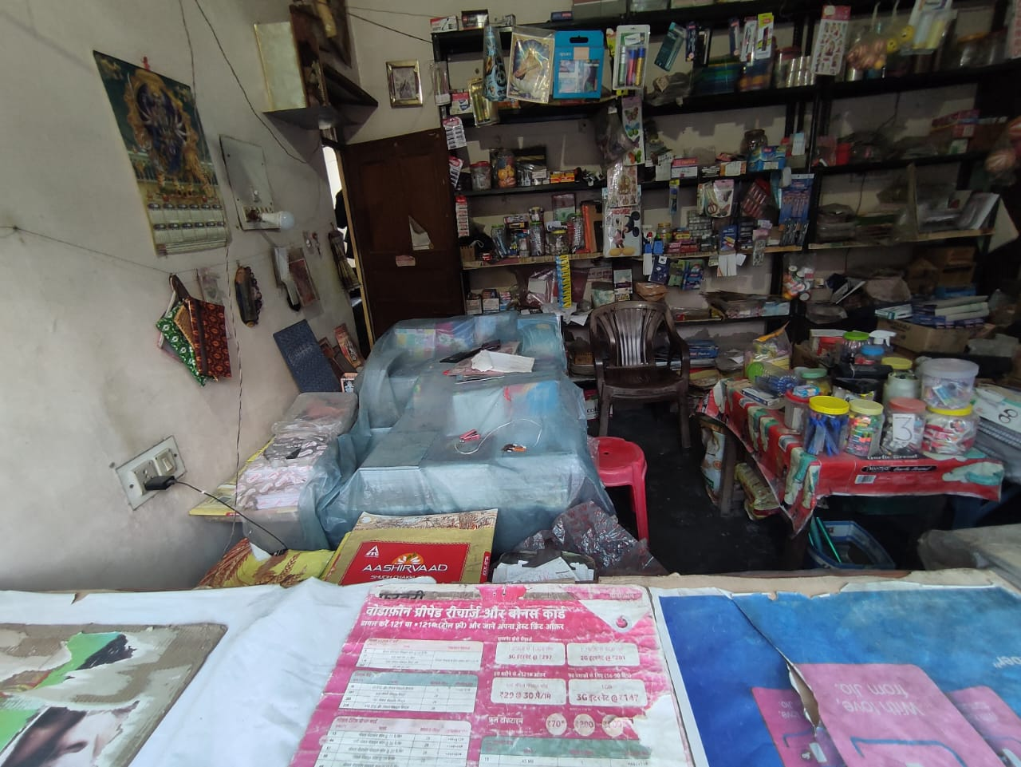 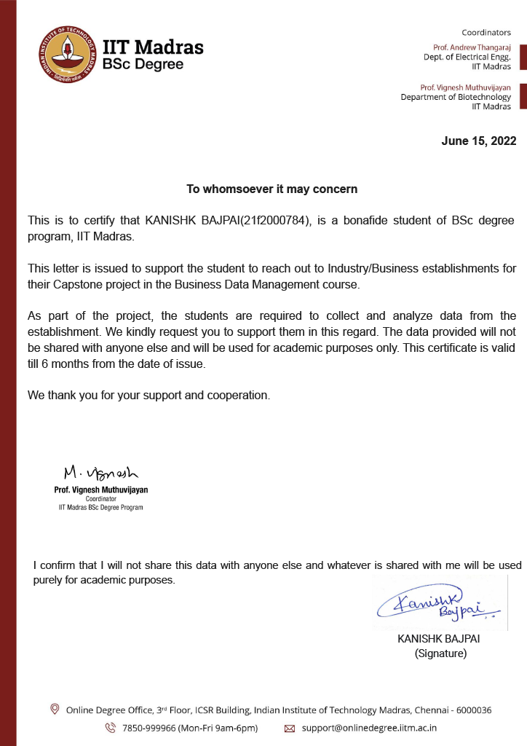

[Stationery Sales](https://docs.google.com/spreadsheets/d/1RTkyi8UMs-HI-HT_Q220cutizNWrR9ICXyFosw5dYVI/edit#gid=393801185)  
[Click here to see the DataSet](https://docs.google.com/spreadsheets/d/1RTkyi8UMs-HI-HT_Q220cutizNWrR9ICXyFosw5dYVI/edit?usp=sharing)

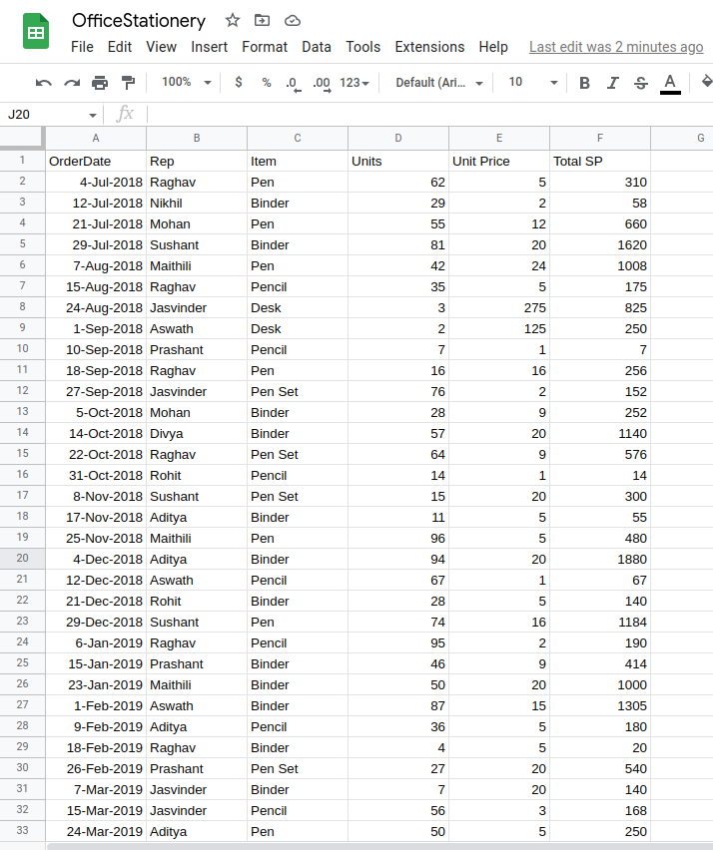

# Metadata & Descriptive Statistics

I have attached a ScreenShot of my DataSet   
  
  
  
I have attached Pivot table out of my DataSet below  
  
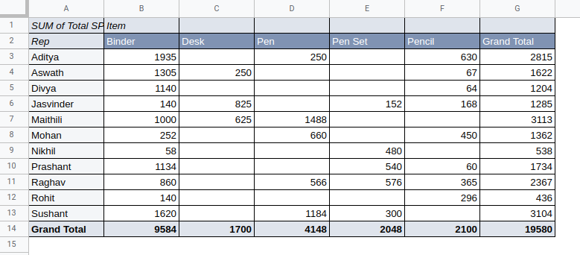  
  
  
I have attached Pie Chart of the DatSet of Customers V/s Items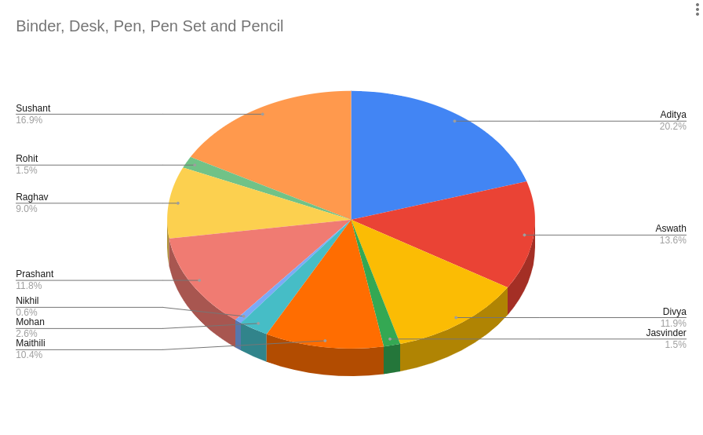

# 4.Detailed Explanation of Analysis Process/Methods

The above collected data can be analyzed using the Pivot Table Analysis and Charts function present in Google SpreadSheet.

* Firstly finding Highest/Lowest Sale through a particular customer.
* Secondly using the Pareto analysis which is premised on the idea that 80% of a profit can be achieved by selling 20% of the Items.
* Thirdly I will try to implement Scrap Analysis in the DataSet, since I am trying to upload it manually in a spreadsheet, it will take some time to analyze.
* After that I will calculate OEE(Overall Equipment Effectiveness), in the process of sale from ***Manufacturer to Customer.*OEE = Availability ✕ Performance ✕ Quality**

# 

# 

# 5. Results & Findings

K

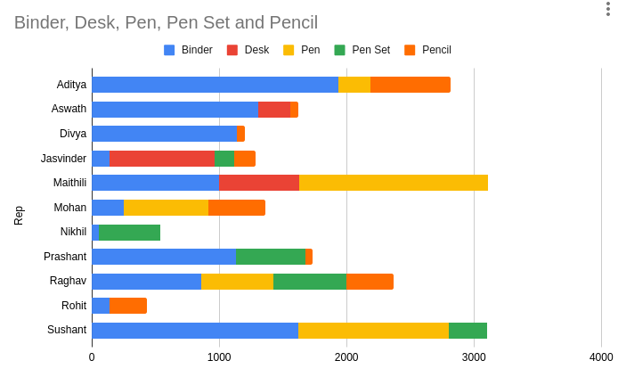

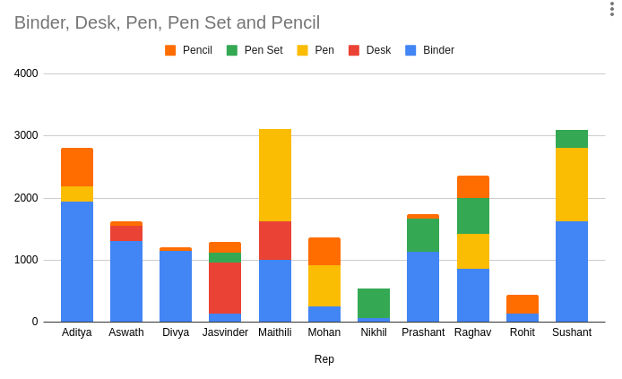

# Total Purchase by Maithili, Sushant & Aditya is among highest **around** 3000 Rs each.

Pareto Principle states that 80% of the sale is through your 20% of the customers, but if see our Dataset, it is not applicable as if we take total sale of top 3 customers then it is around 9000 Rs, but Grand total is around 19000 Rs which comes out to be 48% .  
Because the sample size that I have got for this project is small.

**Sale also majorly depends on:**

1. Market competency,
2. Geographic location,
3. Method of transaction,
4. Online Availability
5. Ease of availability of the stock,
6. Shop timing,
7. Customer Service & Relationship,

These are also to be analysed,

**Market competency** is high, because there are stationery shops nearby which affect the sales

**Geographic Location**: There are few schools and one college within 1 km radius of the shop.

**Method of Transaction**: It is a major problem in this business, because many businesses nowadays nearby use UPI transaction as an additional mode of transaction, but this shop supports only on cash transactions.

I will help my uncle in establishing the UPI transaction system, to go cashless.

**Online Availability**: Some of the premier shops in the market already in exist in the world of internet with their own website, and customer services, but this shop doesn't have any online visibility or marketing.

I will try my best to create an online shopping website, selling in Amazon/Flipkart to get more customers and reachability.

short dash